Muhammad Saleem
Hashmi colony gulzar town chah koray wala Multan. | Phone 0313-6569459/ 0303-7588891  E-mail saleemmalik78601@yahoo.com
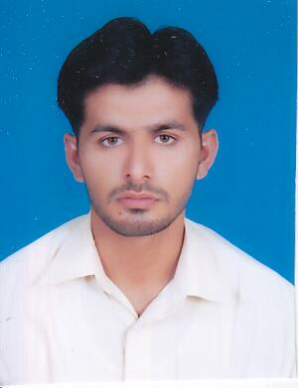
Objective | Prove my self as responsible, valuable and trustworthy member of the professional team by continues learning and hard work. Seeking a challenging within an Organization / Company offering. Excellent prospects for career growth and personal development.
Personal information | Father Name : Muhammad Rafique  Date of Birth : 28-06-1990  CNIC No. : 36303-4757858-9  Domicile : Multan (Punjab)  Religion : Islam  Nationality : Pakistani  Marital Status : Single
Education
  Degree | Marks | P/Year | Board/university
  M.Com | Continue |  | I.U. Bahawalpur
  B.Com | 848/1500 | 2010 | B.Z.U Multan
  I.Com | 650/1100 | 2008 | B.I.S.E Multan
  Matric | 503/1050 | 2006 | B.I.S.E Multan
Computer skills | Ms Office(ms word, ms excel, ms access, ms power point)  Internet browsing  Windows XP installation.
Work experience | Work as a training student in a chartered accountant firm (M.A Hadi & Co.) for 3 months.
Hobbies | Reading News Paper.  Book Reading  Badminton
References | Will be provided on demand.

